Os week 1

**FCFS:**

**PROGRAM :**

|  |
| --- |
| **n=int(input()) p=list(map(str,input().split())) at=list(map(int,input().split())) bt=list(map(int,input().split())) at1=at.copy() gt=[] ct=[0]*n tat=[0]*n wt=[0]*n   k=min(at) ind=at.index(k) gt.append(p[ind]) ct[ind]=bt[ind] tat[ind]=ct[ind]-at[ind] wt[ind]=tat[ind]-bt[ind] at[ind]=99999 pre=ind i=0 while i<n-1:  r=min(at)  rind=at.index(r)  kk=ct[pre]  kkk=at[rind]  if(at[rind]<=ct[pre]):  ct[rind]=ct[pre]+bt[rind]  elif(at[rind]>ct[pre]):  ct[rind]=at[rind]+bt[rind]  gt.append(p[rind])  tat[rind]=ct[rind]-at[rind]  wt[rind]=tat[rind]-bt[rind]  pre=rind  at[rind]=999999  i+=1  print("-----") for i in range(0,n):     print("|",gt[i],end="|")  print() print('Average completion time is \t:',sum(ct)/n) print('Average turn around time is \t:',sum(tat)/n) print('Average waiting time is \t:',sum(wt)/n) print("process id\tat\tct\tbt\ttat\twt\n") for i in range(0,n):  print(p[i],"\t\t",at1[i],"\t\t",bt[i],"\t\t",ct[i],"\t\t",tat[i],"\t\t",wt[i])** |

Output:

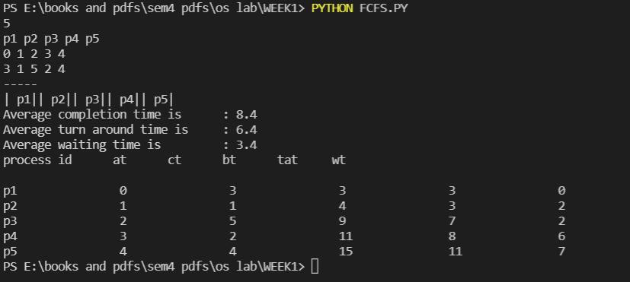

**SJF:**

**PROGRAM:**

|  |
| --- |
| **n=int(input()) p=list(map(str,input().split())) at=list(map(int,input().split()))** |

|  |
| --- |
| **bt=list(map(int,input().split())) #shortest job bt1=bt.copy() k=min(at) ind=at.index(k) gt=[] tat=[0]*n wt=[0]*n ct=[0]*n gt.append(p[ind])   ct[ind]=bt[ind] tat[ind]=ct[ind]-at[ind] wt[ind]=tat[ind]-bt[ind]  bt[ind]=999999 pre=ind i=1 while i<n:  r=min(bt)  rind=bt.index(r)  if at[rind]<ct[pre]:  ct[rind]=ct[pre]+bt[rind]  pre=rind  tat[rind]=ct[rind]-at[rind]  wt[rind]=tat[rind]-bt[rind]  gt.append(p[rind])  # print(rind,at[rind],ct[pre],gt[rind])  bt[rind]=999999  i+=1 print("-----") for i in range(0,n):  print("|",gt[i],end="|") print() print('Average completion time is \t:',sum(ct)/n) print('Average turn around time is \t:',sum(tat)/n) print('Average waiting time is \t:',sum(wt)/n)  print("process id\tat\tct\tbt\ttat\twt\n") for i in range(0,n):  print(p[i],"\t\t",at[i],"\t\t",bt1[i],"\t\t",ct[i],"\t\t",tat[i],"\t\t",wt[i])** |

Output:

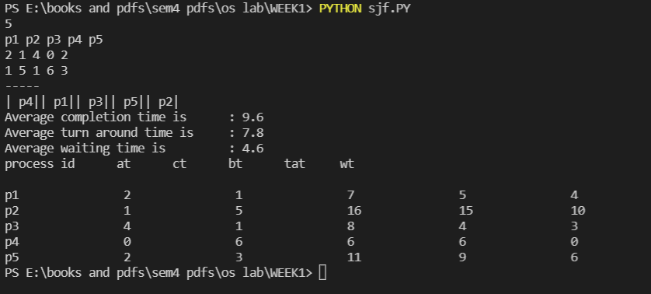

**Round robbin:**

**Program:**

|  |
| --- |
| **n = int(input("enter number of process : ")) process = list(map(str, input("enter process names : ").split())) Arrival_time = list(map(int, input("enter arrival time : ").split())) Burst_time = list(map(int, input("enter burst time : ").split())) t = int(input("Time Quantum : ")) Atl = sorted(Arrival_time) Bt1 = Burst_time.copy() gantt_chart = [] ready_queue = [] completion_time = [0]*(n) waiting_time = [0]*(n) turn_around_time = [0]*(n) response_time = [0]*n val = cnt = flg = i = 0 s = sum(Burst_time) while (max(completion_time)!=s):  while(i<len(Atl) and cnt>=Atl[i]):  ready_queue.append(Atl[i])  i+=1  if flg==1:  ready_queue.append(Arrival_time[x])  x = Arrival_time.index(ready_queue[0])  if process[x] not in gantt_chart:  response_time[x] = val-Arrival_time[x]  gantt_chart.append(process[x])  ready_queue.remove(Arrival_time[x])  if Burst_time[x]<=t and Burst_time[x]!=0:  completion_time[x] = Burst_time[x] + cnt  turn_around_time[x] = completion_time[x]-Arrival_time[x]  waiting_time[x] = turn_around_time[x]-Bt1[x]  val += Burst_time[x]  cnt +=Burst_time[x]  Burst_time[x]=0  flg=0   else:  Burst_time[x] = Burst_time[x]-t  cnt+=t  val = cnt  flg=1 print("Process ArrivalTime BurstTime CompletionTime TurnAroundTime WaitingTime ResponseTime") for i in range(0,len(process)):  print(" ",process[i]," \t",Arrival_time[i]," \t",Bt1[i],"\t\t",completion_time[i]," \t",turn_around_time[i],"\t\t",waiting_time[i],"\t",response_time[i])  print("Gantt Chart :",gantt_chart) print("Avg Turn Around Time:", round(sum(turn_around_time)/n,3)) print("Avg Wating Time :", round(sum(waiting_time)/n,3))** |

Output:

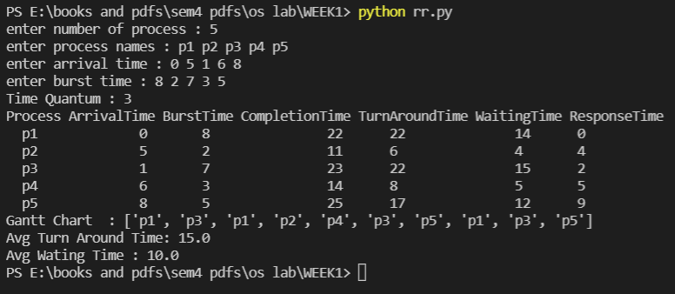

**Priority scheduling:**

**Program:**

|  |
| --- |
| **n=int(input()) p=list(map(str,input().split())) pr=list(map(int,input().split())) at=list(map(int,input().split())) bt=list(map(int,input().split())) pr1=pr.copy() gt=[] ct=[0]*n tat=[0]*n wt=[0]*n  ind=at.index(min(at)) pr[ind]=999999 ct[ind]=bt[ind] gt.append(p[ind]) tat[ind]=ct[ind]-at[ind] wt[ind]=tat[ind]-bt[ind]  pre=ind  while ct[pre]!=sum(bt):  rind=pr.index(min(pr))  if at[rind]>ct[pre]:  pr1[rind]=999999  rind=pr1.index(min(pr1))  ct[rind]=ct[pre]+bt[rind]  pre=rind  tat[rind]=ct[rind]-at[rind]  wt[rind]=tat[rind]-bt[rind]  pr[rind]=999999  gt.append(p[rind])  print("-----") for i in range(0,n):  print("|",gt[i],end="|") print()  print("process id\tat\tct\tbt\ttat\twt\n") for i in range(0,n):  print(p[i],"\t\t",at[i],"\t\t",bt[i],"\t\t",ct[i],"\t\t",tat[i],"\t\t",wt[i])** |

Output:

